Creating a DockerFile SOP



Table of Contents

1. Creating a DockerFile 3
1.1 Description 3
1.2 Architecture Diagram 3
1.3 Lab Steps 4
1.4 Troubleshooting 5
1.5 Supporting References 5

Creating a DockerFile

Description
Docker can build images automatically by reading the instructions from a Dockerfile. A Dockerfile is a text document that contains all the commands a user could call on the command line to assemble an image. Using docker build users can create an automated build that executes several command-line instructions in succession. The docker build command builds an image from a Dockerfile and a context
In this lab exercise, we will build a simple Dockerfile and also understand how we can use other scripts inside the file.

Architecture Diagram
The diagram below displays a visual representation of the application architecture:

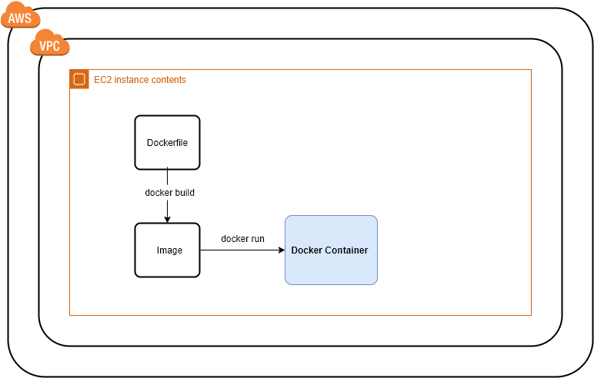

Lab Steps
Follow the steps outlined below to achieve the objective of this lab exercise:

- Install docker:
  - Create an EC2 instance from which we will create a dockerzied application.
  - Navigate to EC2 console and Launch an Amazon Linux 2 instance.
  - Once instance is launched and is running, SSH into the instance either using PuTTY or directly from the console using Session Manager by attaching CCL-EC2-Role.
  - Install docker if not already installed:
    - yum update -y
    - sudo yum install -y docker
    - docker –v
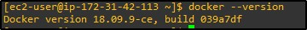
    - service docker status
    - sudo service docker start
    - usermod -a -G docker ec2-user

- Create a Dockerfile:
  - Create a file named Dockerfile and add the following commands into the file:
FROM ALPINE
CMD [“echo”,”hello world”]
  - Build the docker file now. Run command will turn image into container. Remember to add a dot (.) at the end which represents the current folder:
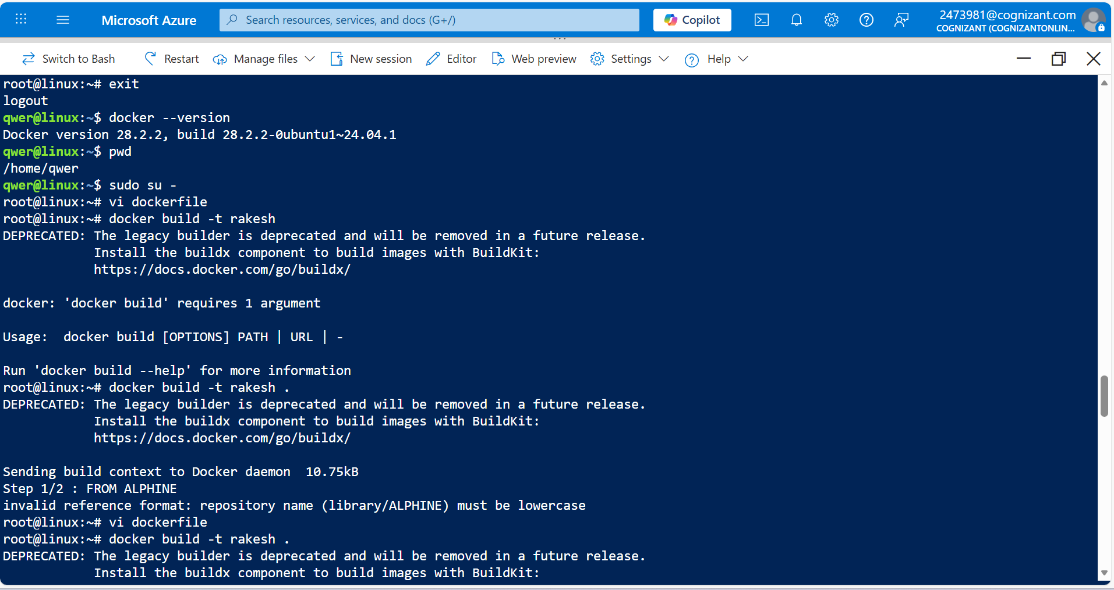
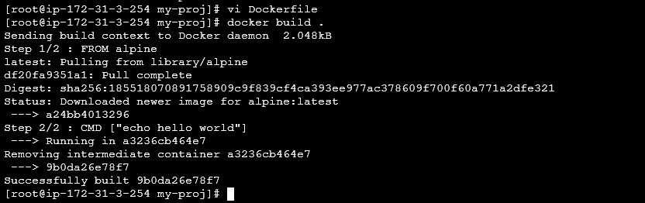

docker build .

  - Run the image built in the previous step. The docker run command is the command used to launch Docker containers:
docker run --name <any-name> <image-id>
  - Create another file named script.sh file and the following code:
#! /bin/sh

echo Hi from another scirpt file
  - Make the file executable by giving chmod +x %
  - Re-edit the Dockerfile now. The following code says that the docker container will have a file under /script.sh:
FROM ALPINE
COPY script.sh /script.sh CMD [“script.sh”]
  - Build the image again with the new Dockerfile. While building you can find that the file is being copied.
docker build .
  - Run the docker image:
docker run –-name <any-name> <image-id>
You can find that the output is coming from script.sh file which is not included in Dockerfile.
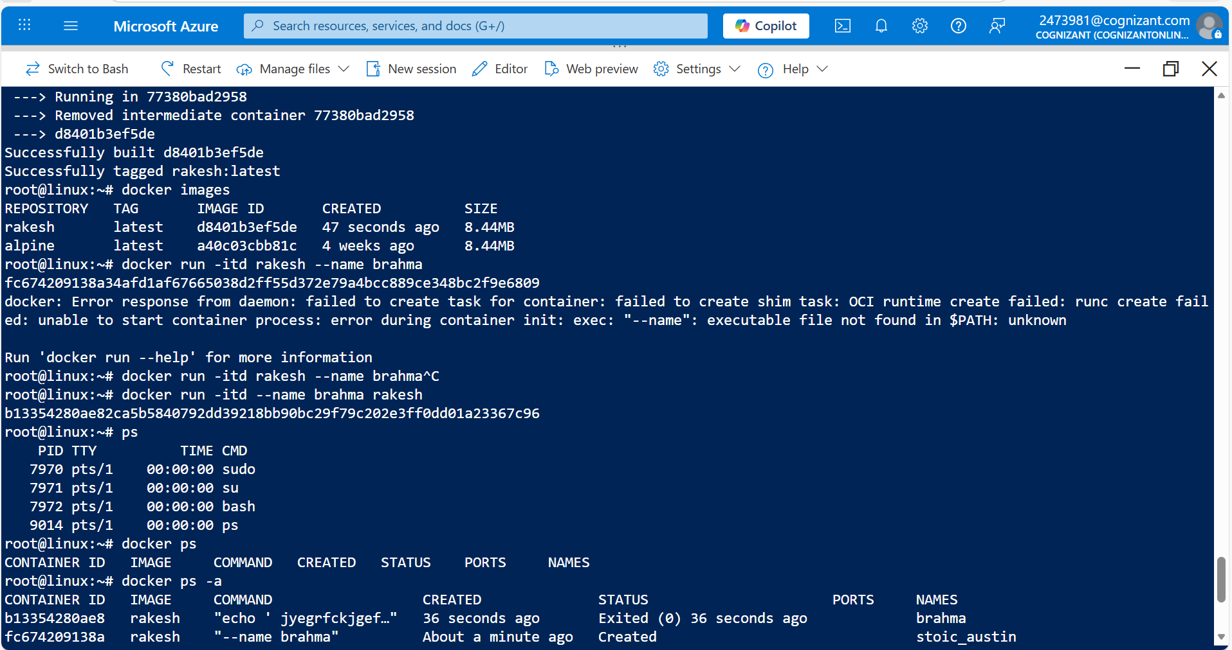
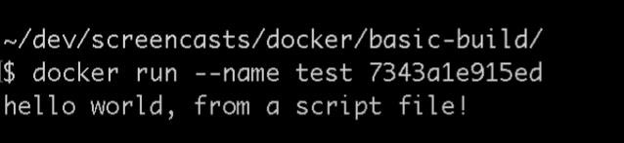

Troubleshooting
S. No | Problem | Solution
1 | Docker Build failed | Make sure that your Dockerfile is named with the uppercase D, because docker build recognizes by that name.
2 | My build fails | Check the correctness of Dockerfile syntax.

Supporting References
Refer the below link for additional information:

- https://docs.docker.com/engine/reference/builder/
